Session 1: Building the Foundations for Learning
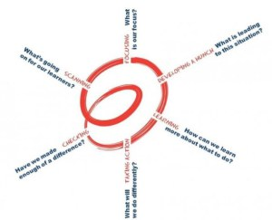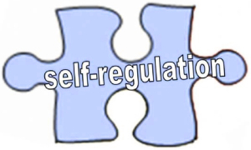
In this session the focus will be on developing a shared understanding of what it means to build a strong primary classroom foundation for literacy. Topics will include:
- Teacher Inquiry
- Engaging the Literacy Learner (motivation/engagement theory)
- Self-Regulated Learning
- Indigenizing the Curriculum
- Exploring Reading Myths
PowerPoint Presentation: CR4YR Session 1 Feb 4 2015
Hand-outs:
Allington What Really Works for Struggling Readers[1] (DOC)
John Hattie’s Ranking of Influences on Student Learning (LINK: http://visible-learning.org/hattie-ranking-influences-effect-sizes-learning-achievement/)
Fearless Inventory
FN Principles of Learning
Student Case Study 1
Supporting Self Regulation in School
What is self regulated learning-
Other Resources and Websites:
Foundations of Literacy
Visible Learning – John Hattie’s website (LINK: http://visible-learning.org/)
Reciprocal Teaching Strategy (Reading Rockets) (LINK: http://www.readingrockets.org//strategies/reciprocal_teaching)
Response to Intervention (RTI Action Network) (LINK: http://www.rtinetwork.org/learn/what/whatisrti)

