Session 3: Core Components of Literacy Instruction Part 2
Sessions 2 and 3 will focus on the Core Components of Literacy Instruction. In Part 2 we will explore the following components:
- Vocabulary Comprehension
- Passage Comprehension
- Guided Reading
- Fluency
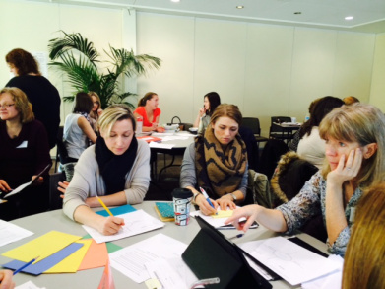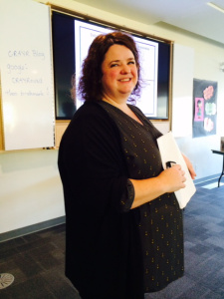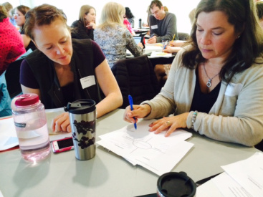
Invitations to Wonder…
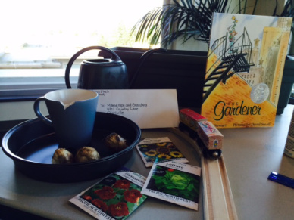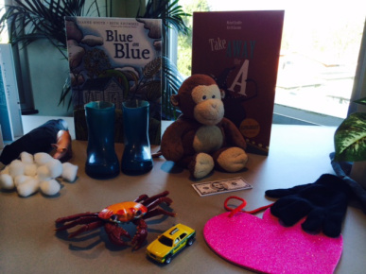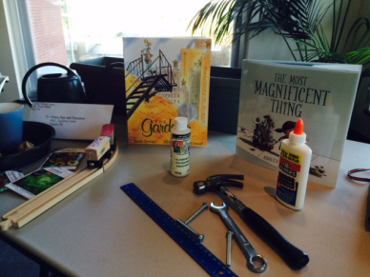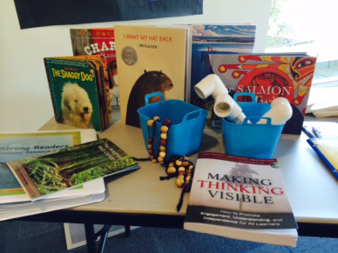
PowerPoint Presentation: ##CR4YRSession 3_Final 2015 [Autosaved] [Autosaved]
Hand-outs: (to follow)
Developing Fluent Readers in the Primary Grades
Frayer Model
Taking Cabbages on Leashes for Walks
Things Every Teacher Should Know about Words and Vocabulary Instruction
Ressources en français:
Carte de stratégies de lecture
Inventaire de la conscience phonologique
Le modèle de Frayer
Le transfert progressif de la responsabilité
Les compétences de base de la lecture
Promener des choux en laisse
Schéma Capteurs de sens en lecture
Give Away – Thanks to Claire Spofforth for the lovely gift of the Reading Beads!!
