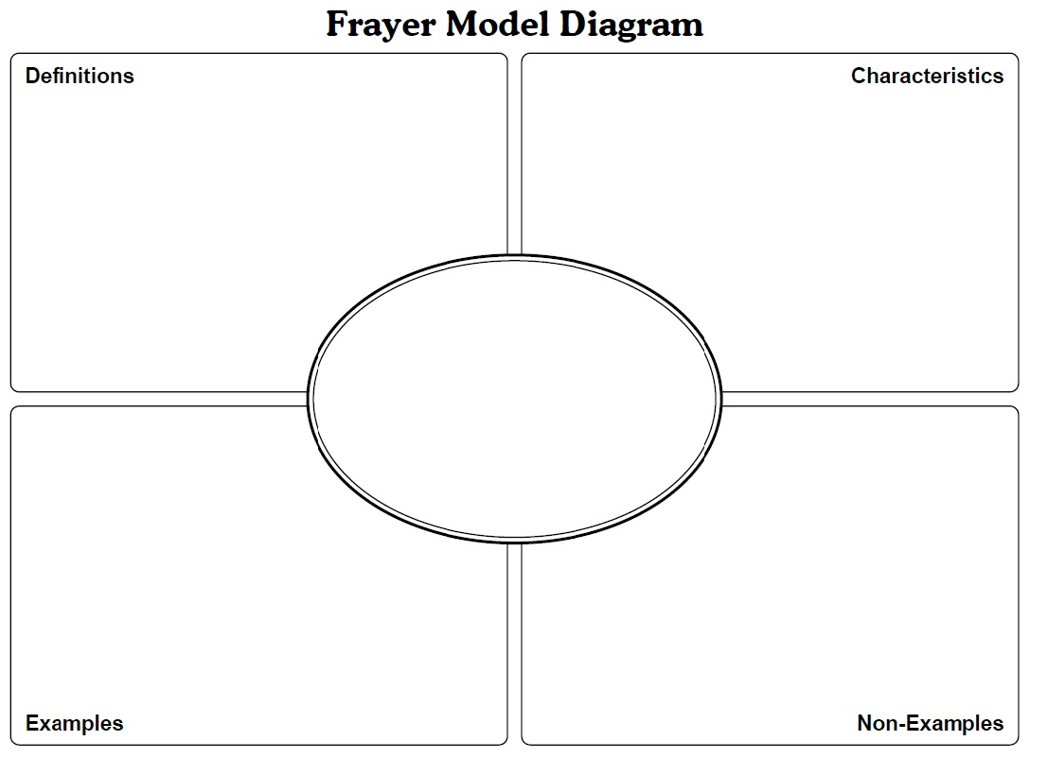
Word:

My Teacher’s Description | My Description
How I Will Remember This Word | Additional Experiences/Connections

